SCHOOL OF COMPUTER SCIENCE AND ARTIFICIAL INTELLIGENCE |  |  |  |  | DEPARTMENT OF COMPUTER SCIENCE ENGINEERING
Program Name: B. Tech |  |  |  | Assignment Type: Lab |  |  | Academic Year:2025-2026
Course Coordinator Name |  |  |  | Venkataramana Veeramsetty
Instructor(s) Name
  Dr. V. Venkataramana (Co-ordinator)
  Dr. T. Sampath Kumar
  Dr. Pramoda Patro
  Dr. Brij Kishor Tiwari
  Dr.J.Ravichander
  Dr. Mohammand Ali Shaik
  Dr. Anirodh Kumar
  Mr. S.Naresh Kumar
  Dr. RAJESH VELPULA
  Mr. Kundhan Kumar
  Ms. Ch.Rajitha
  Mr. M Prakash
  Mr. B.Raju
  Intern 1 (Dharma teja)
  Intern 2 (Sai Prasad)
  Intern 3 (Sowmya)
  NS_2 ( Mounika)
Course Code |  |  | 24CS002PC215 | Course Title |  | AI Assisted Coding
Year/Sem |  |  | II/I | Regulation |  | R24
Date and Day  of Assignment |  |  | Week11 - Monday | Time(s)
Duration |  |  | 2 Hours | Applicable to  Batches
AssignmentNumber:21.1(Present assignment number)/24(Total number of assignments)
 | Q.No. | Question |  |  |  |  |  | Expected Time  to complete
 | 1 | Lab 21 – Collaborative AI Coding: Pair Programming and Version Control Integration  Lab Objectives:  - Learn to use AI as a pair programmer for writing, reviewing, and optimizing code.  - Understand how to integrate AI-generated code into version control systems (Git).  - Practice collaborative workflows such as commit messages, branching, and merging.  Task 1 – AI-Assisted Pair Programming  - Use AI to generate an initial program (e.g., a simple To-Do List Manager).  - Ask AI to suggest enhancements (such as error handling, additional features, or refactoring).  - Compare the original and improved versions to understand the role of AI in collaboration.  Prompt:  Generate a simple Python program for a To-Do List Manager that lets users add, view, and remove tasks using input. Then improve it by adding error handling, input validation, and friendly messages. Finally, explain line by line how the improved version differs from the original.  Original version Code:  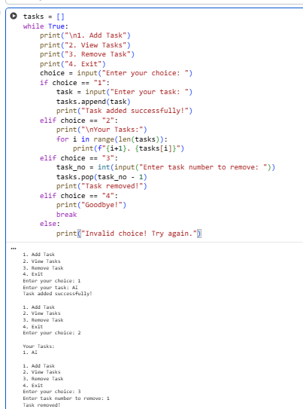  Improved (AI-Assisted) Version:  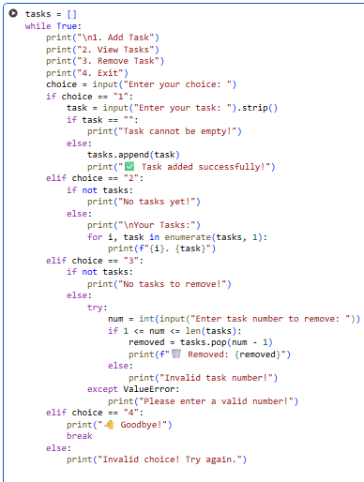  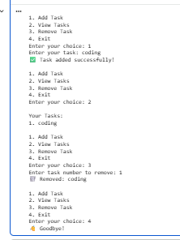  Comparison:  The improved version adds input validation and error handling to prevent crashes from invalid inputs.  It also checks for empty task lists, uses cleaner loops, and gives clearer, user-friendly messages.  Overall, it’s safer, more reliable, and easier for beginners to use than the original version.  Task 2 – Version Control Integration  - Initialize a Git repository for your project.  - Perform the following steps:  - Create and switch to a new branch.  - Add AI-assisted modifications.  - Commit with a meaningful message.  - Merge changes back into the main branch.  - Reflect on how version control supports collaborative development with AI assistance.  Prompt:  Version Control Integration.  Initialize a Git repo, make a new branch for AI edits, commit the changes, merge them back.  Code:  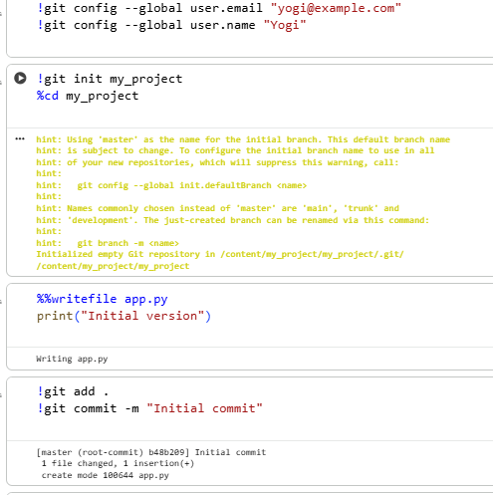  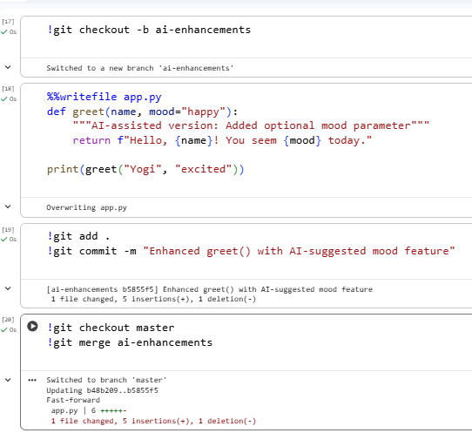  Reflection:  Version control ensures safe collaboration between human developers and AI tools.  By using branches, developers can test AI-generated improvements separately, review changes,  and merge them only when validated. This keeps the main project stable and traceable.  Task 3 – AI for Commit Message Generation  - Use AI to generate concise, meaningful commit messages based on the changes made.  - Compare AI-generated messages with human-written ones.  - Discuss how AI can improve documentation and traceability in Git history.  Prompt:  Create a clear commit message for this change: <briefly describe what you changed and why>  AI-generated  refactor: rename process_data() to process_input and fix empty-input crash  - renamed function for clearer intent  - added input validation to prevent crash on empty input  - added unit test for empty input case  Human-written  Rename function and guard empty inputs  Renamed process_data to process_input and added a check so empty inputs don't raise an exception. Added a unit test.  How AI improves commit documentation and traceability  AI helps generate concise, consistent commit messages that follow conventions (e.g., feat/, fix/, refactor/). It speeds up writing by extracting the “what” and “why” from diffs and encourages including a short body that documents rationale and risk. This improves traceability: reviewers and future developers can quickly understand intent, automated tools can parse commit types, and the project history becomes easier to search and audit. Human review is still important to ensure correctness, tone, and privacy (don’t include secrets in commit messages).  Task 4 – Pair Programming Simulation  - Student A writes the initial version of a program.  - Student B, with AI assistance, suggests improvements or adds features.  - Both students collaborate using Git branching and merging to integrate their work.  Prompt:  As Student B, suggest improvements or add a new feature to this program. Provide clean code and a meaningful commit message for the update.  Code  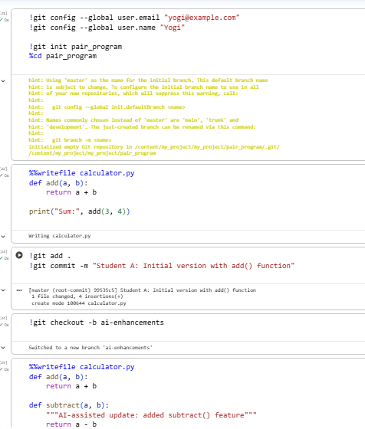  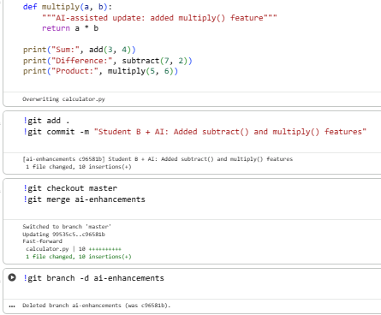  ✅ Deliverables (For All Tasks)  - AI-generated prompts for code and test case generation.  - At least 3 assert test cases for each task.  - AI-generated initial code and execution screenshots.  - Analysis of whether code passes all tests.  - Improved final version with inline comments and explanation.  - Compiled report (Word/PDF) with prompts, test cases, assertions, code, and output. |  |  |  |  |  | Week11 - Monday

